

*Formula Student ATA*

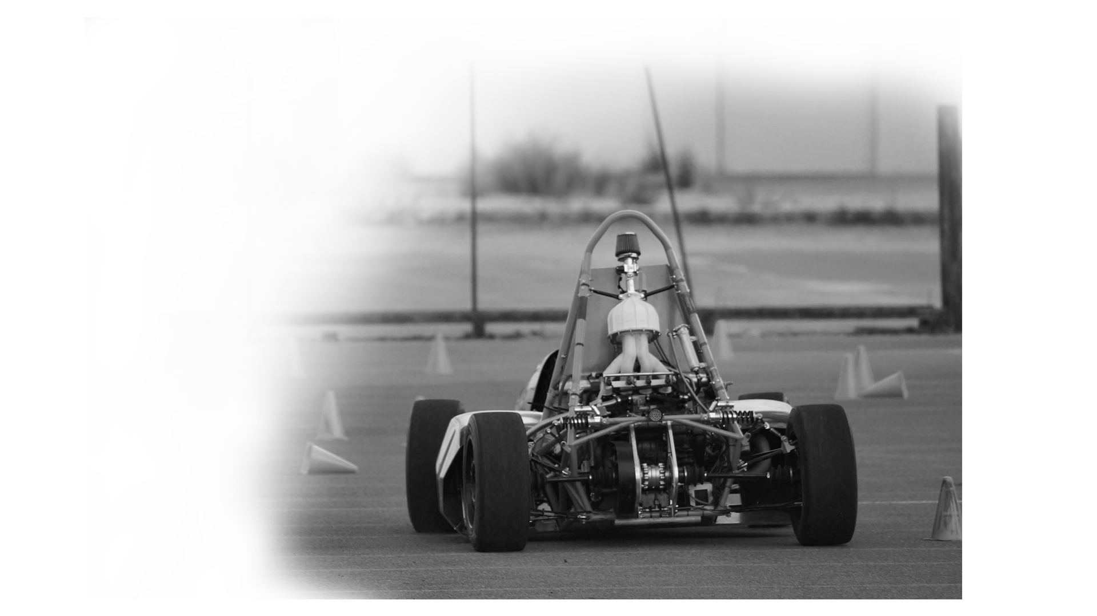

*Professionnal seminar organizer*

**BUSINESS PLAN**

TEAM EPSA

SUMMARY

I. Executive Summary 4

II. Presentation of the company 5

II. 1. Overview 5

III. Market analysis 7

III. 1. Market Status 7

III. 2. Our position 8

III. 3. Internal and external analysis 9

IV. Our business 11

IV. 1. Offers 11

IV.1.1 Overview 11

IV.1.2 Details 11

IV. 2. The reference car 13

V. Objectives and strategy 15

V. 1. Objectives (What) 15

V. 2. Strategy (How) 15

V. 3. Communication 16

V.3.1 Social networks 16

V.3.2 Off-line communication 17

VI. Planning stage 18

VII. Financial aspects 18

VII.1. General course of action 18

VII.2. Fixed costs 19

VII.2.1 Marketing and communication 19

VII.2.2 Real estate 19

VII.2.3 Wages 20

VII.2.4 Reference car 21

VII.2.5 Furniture 21

VII.2.6 Company car for commercials 21

VII.2.7 Additional parts and kits 22

VII.2.8 Toolings 22

VII.2.9 Website 22

VII.2.10 Accounting 22

VII.2.11 Brand protection 22

VII. 3. Variable costs 23

VII. 4. Profit and losses 25

VII. 5. Financial analysis of the company 27

VII.5.1 Input data 27

VII.5.2 Statement of income 28

VII.5.3 Cash flow statement 28

VII.5.4 Balance sheet & and indicators 29

VII.5.5 Graphs 30

VII.5.6 Financial summary 32

VIII. Legal aspects 33

VIII. 1. Setting up a private limited company 33

VIII. 2. Ownership 33

VIII. 3. Profit and tax 34

VIII.3.1 Registering a limited company 34

VIII.3.2 Filing the companyis accounts tax return 34

’ 34

VIII. 4. Authorsis rights 34

VIII. 5. Trademark 34

VIII. 6. Employed staff 35

VIII. 7. Register employees with Work inspection 35

IX. Conclusion 36

X. Appendix 37

X.1 Financial aspects : the low hypothesis 37

X.1.1 Fixed costs 37

X.1.2 Variable costs 38

X.1.3 Profit and losses 38

X.1.4 Fiancial analysis : Input data 40

X.1.5 Statement of income 41

X.1.6 Cash flow statement 41

X.1.7 Balance sheet & indicators 42

# Executive Summary

Nowadays firms are looking to increase the productivity of their employees. To reach this goal, they need to motivate their teams to get the most of them. In this context, teambuilding seminars know a growth in their popularity. Indeed, it has become a growing evidence that people are more productive when happy. As this market is growing, and teambuilding is at the heart of management thinking, we decided to target it by proposing an innovative offer.

*Figure I. 1 : the team spirit*

Our Start-up, VULCANIX, offers an exceptional experience which guarantee a group cohesion during the whole seminar. We propose Vehicle Assembly Seminars for firms which seek to offer an original team building experience to their employees around the assembly and driving of a formula type vehicle.

These seminars combine workgroup, decisions taking and a common goal for all the participants which lead to concrete realization : a race car that they will drive at the end of the project. These seminars make the participant focus on tasks which impact directly the performance of the car they build. By giving sense to the decisions they make, choosing different concepts, communicating and generating a strong team spirit, these seminars constitute excellent tools for team building.

To attract companies, we have several strategies. A salesman whose mission is to visit companies to present them our concept, a website which explains the different steps of the seminars, shows some videos of the previous seminar and host a forum where the participants can give their opinion about it. In order to reach our target customers, we will use social network such as LinkedIn, so we can catch professional s attention. We will also participate to team building exhibition to attract clients. In a second time, we will create partnerships with some event organizing companies so they will be able to propose our seminars in their catalogue.

’

# Presentation of the company

## II. 1. Overview

VULCANIX is a start-up founded in January in Lyon, France. It aims to offer **incentive seminars** based on a race car vehicle : Vulcanix.

VULCANIX is a company led by four students at ECOLE CENTRALE DE LYON who are eager to be part of the great adventure of entrepreneurship. We are all passionate about the new technologies, cars, high sensations, but we are also very attached to safety and serious work. We have different profiles, binding management, finance, negotiation, marketing and engineering. We are the perfect team to grow this project and make it successful.

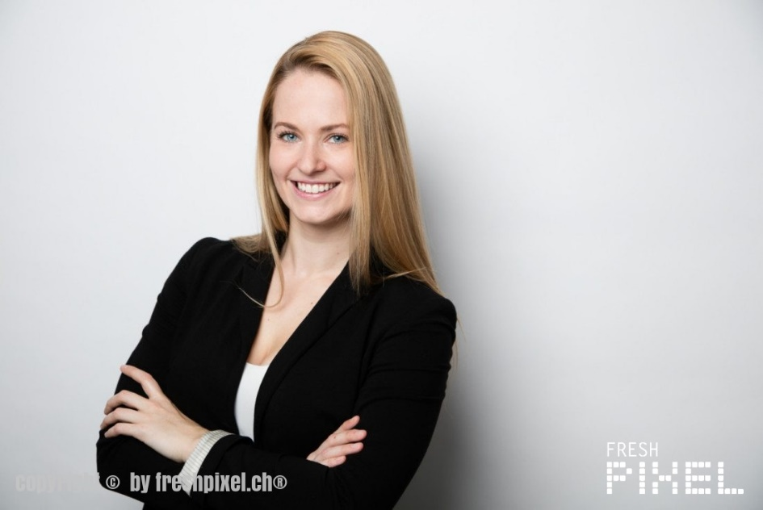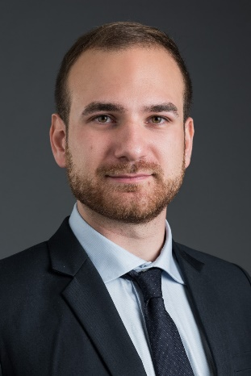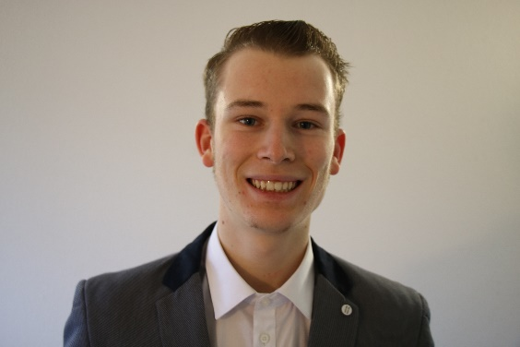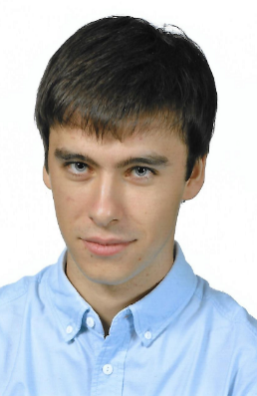

*Figure II.1 : Vulcanix team overview*

Our team gathers both strengths and weaknesses that we are aware of. This makes us more likely to succeed because we know where to concentrate our efforts to overcome any kind of difficulty.

|  |  |  |
| --- | --- | --- |
| Ressouces | Rating | How |
| Technical knowledge |  | *Passionate people with a high engineering training* |
| Marketing structure |  | *Strategy established with performant and accurate people* |
| Flexibility |  | *All car engineering devotees, but one single formation* |
| Quality focus |  | *Always listening to client and earn his/her loyalty* |
| Communication |  | *Dynamic people that favour oral and direct contact* |
| Brand image |  | *Newcomers in an established but increasing market* |
| Profit margin |  | *Increased thanks to the development in Europe* |
| Functional costs |  | *Only need a small office for meetings with clients/partners, and a warehouse* |

*Figure II. 2: Our ressources*

# Market analysis

## III. 1. Market Status

VULCANIX is trying to enter the teambuilding market, by organizing innovative seminars.

First, teambuilding seminars is a growing market. Indeed, the model of a vertical hierarchy is outdated. The fact that employees are more and more skilled make the companies reorganize the tasks. Nowadays, teamwork is companies’ main tool, and the teambuilding market makes the most of this trend.

We noticed that most teambuilding seminars consist in trips to sunny destination with some sensitization conferences and enjoyable activities. We wanted to change that by proposing an offer which gives the participants the awareness of belonging to a single team even if people donit achieve the same tasks, just as in their daywork.



*Companies send us their employees, we give them back a team !*

## Résultat de recherche d'images pour "guillemets"III. 2. Our position

We target companies who are looking for a new kind of experience for their employees which will impact efficiently their productivity when they come back. Indeed, the fact that the participants are immersed in an environment that they are unfamiliar with will permit to reveal skills that they do not use in their everyday-life. It will also make them more confident in their professional life, and valori them nearby their co-workers.

In short, companies send us their employees, we give them back a team.

The figure below highlights the main benefits for the employees of our clients, and therefore, the reasons why they should choose our offer.

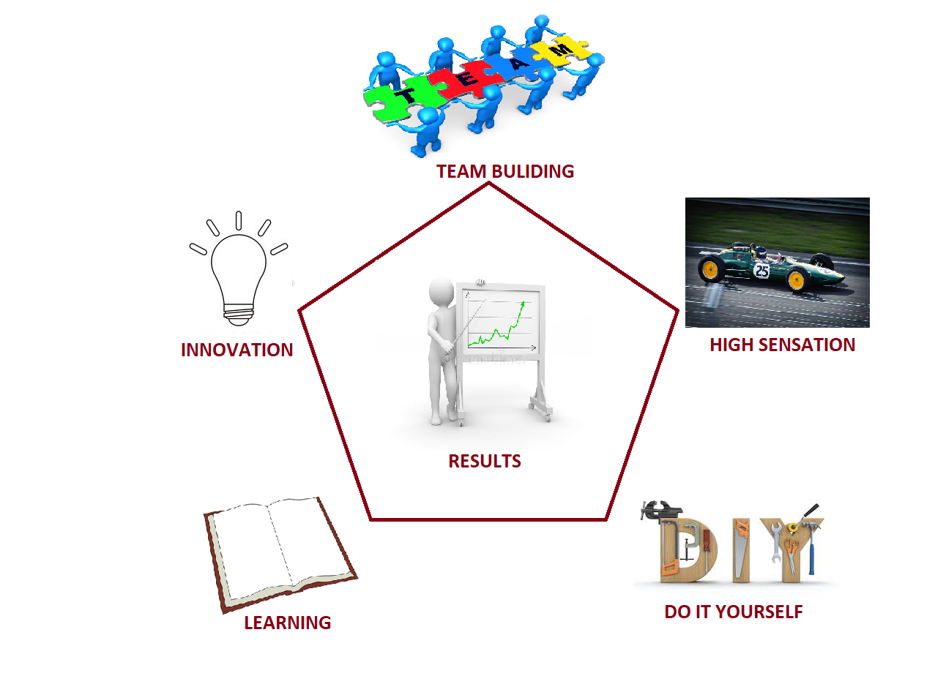

*Figure III. 1: pentagon of success*

## III. 3. Internal and external analysis

SWOT diagram :

Positive

Negative

- Huge network of companies and partners

- Innovation potential

- Originality of the offer

- High engineering background

- Time and cost efficiency

- Dynamic, flexible and skilled team

Internal

*Figure III. 2 : SWOT diagram*

External



**Strengths**

Our offer is original and stands out on the market of seminars. VULCANIX offers a unique experience, based on safety, originality and personalization, high sensation and fun. Overall our seminars strengthen the team spirit of the participants more than any other seminar by putting them in difficulties which force them to give their best as a team, and appreciate the results of their efforts.



**Weaknesses**   
As a start-up offering a new type of seminars, we have a low brand recognition, in a context where people are used to regular seminars in sunny destinations. In addition, more and stricter environmental regulations (noise, pollution) are impacting our concept more than other seminars.



**Opportunities**

Our business idea allows our start-up to grasp - in the future - other market segmentations. With developing tendency of electric car there is a huge space for innovation. We can also export our concept all over the world by targeting international market.



**Threats**

We are in direct competition with specialist of seminar organization that have a recognition on the market and that are trusted by companies.

# Our business

## IV. 1. Offers

### IV.1.1 Overview



Thanks to our market analysis, we propose the following offer: a seminar for around 20 people focusing on teambuilding through the assembly of a race car. Our seminars targets teams of executive officers working for huge companies. The goal is to create a team spirit between them by working on an object they don’t necessarily master, i.e. the building of a race car.

In addition, we will offer the opportunity to drive the assembled vehicle (on race tracks with teaching from professional pilots either half a day or two hours) at the end of the seminar.

### IV.1.2 Details

The seminar will take place in a warehouse where we store all the parts of the vehicle. It is divided into the following steps :

The whole group elaborates a quick specification note, that explains very global performances in a qualitative manner. Connoisseurs will be able to specify quantitative details, but the main purpose here is to focus on qualitative car behavior, such as comfort, acceleration or max speed specialization etc ... An engineer working at VULCANIX will help them to make the pertinent choices depending on the spirit they want to put in their car.



The 20 participants will be split into smaller units to discuss and target one or several of the car’s sub-systems they would like to work on.



As the team work is focused on the assembly of a single vehicle, the different units need to interact each other to reach the global performance that has been anticipated.

We have prepared different options for each system in order to make them experiment the choice of design done by an engineer. For example, they will have the opportunity to choose between different steering wheels, brake discs or springs and dampers.



Eventually, the whole group assembles the car with all the chosen sub-systems, after checking the parts can be assembled together. To facilitate the assembly, and to ensure a lot of possibilities, we would buy standard parts and kits we already know are compatible.

The seminar ends with the driving of the unique vehicle that has been built during the three days of seminar !

## IV. 2. The reference car

The car that will be used to animate the seminars is a typical FSAE car. Here below are its basic characteristics :

**Track (Front/Rear)**: 1276 mm / 1222 mm

**Wheelbase**: 1600 mm

**Mass**: 232 kg

**Gravity center height**: 300 mm

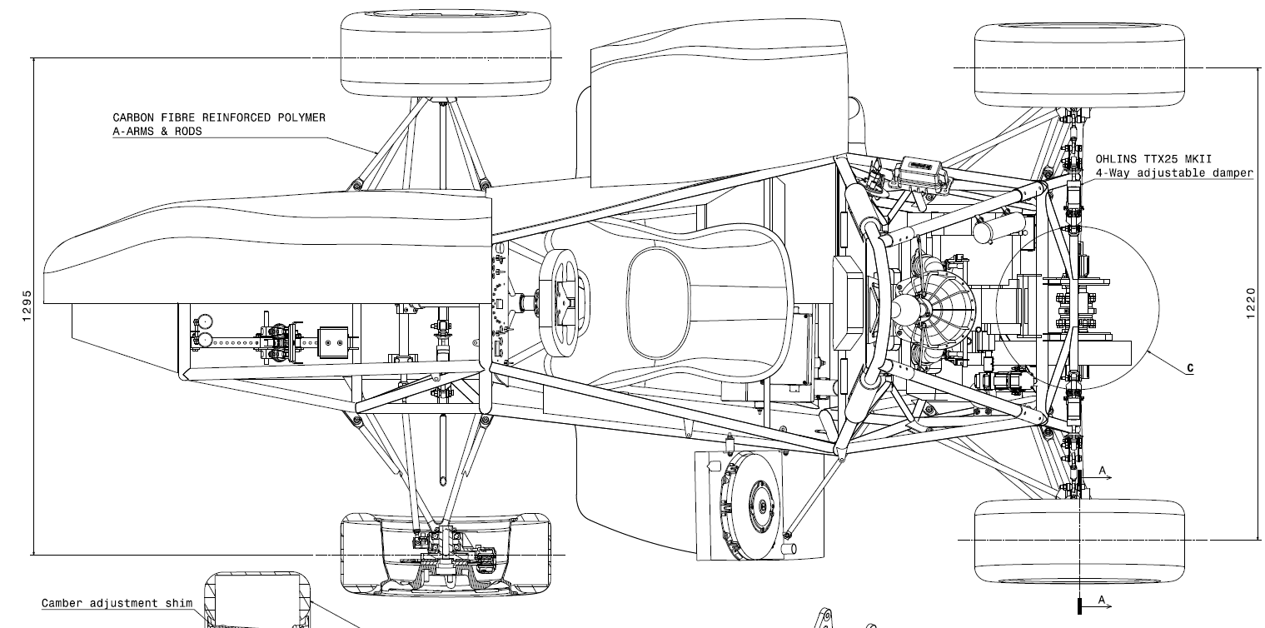

*Figure IV. 1: Reference car - top view*

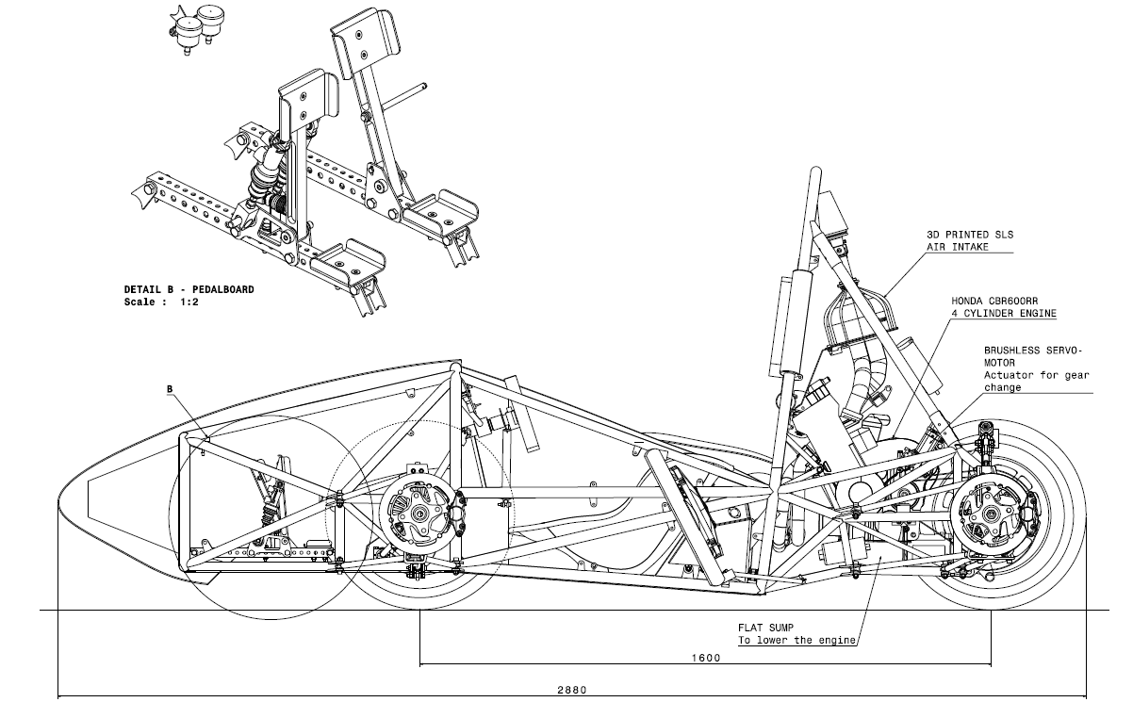

*Figure IV. 2 : Reference car - side view*

**Frame** : 40.5 kg SAE 4130 steel space frame

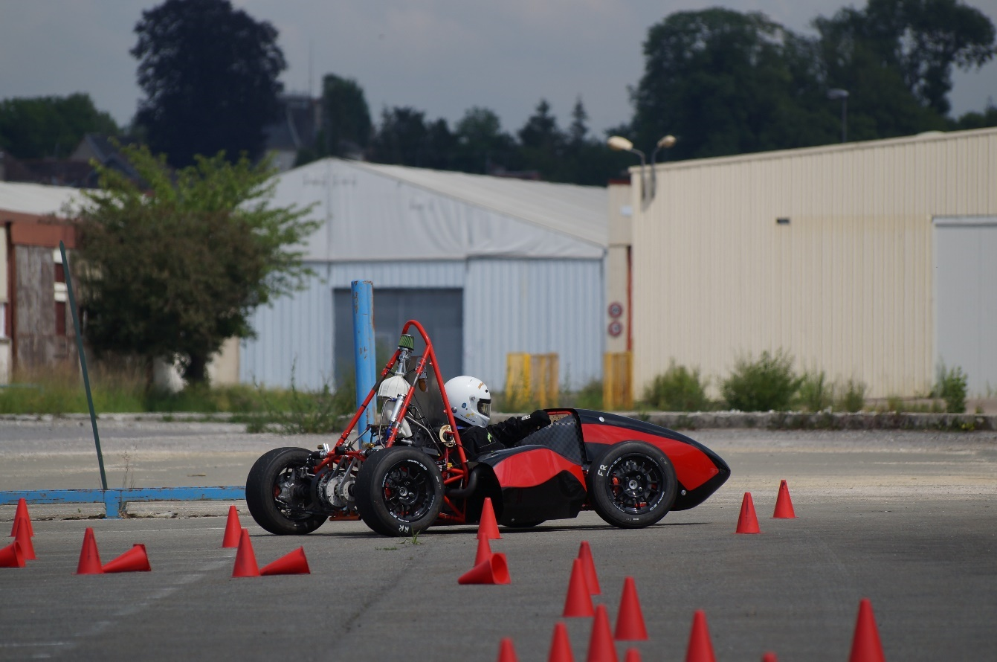

*Figure IV. 3: The reference car on testing*

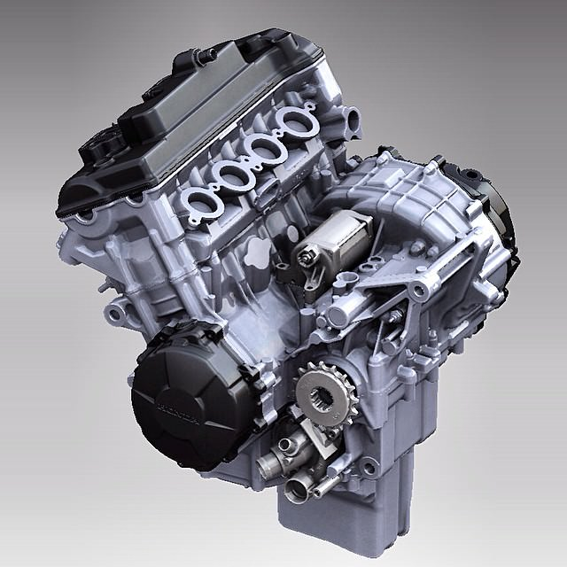

*Figure IV. 4 : The engine*

**Engine**: Honda CBR 600 RR

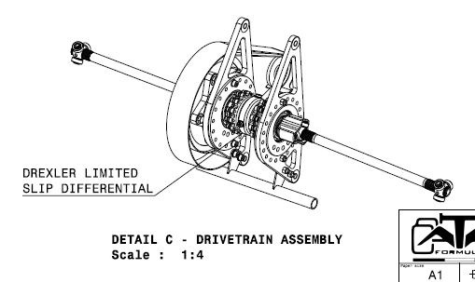

**Differential** : Drexler limited-slip differential

*Figure IV. 5 : The differential*

# Objectives and strategy

## V. 1. Objectives (What)

To make our work easier, we decided to define clear objectives on the long term. To make them clear we defined them according to two criteria: a qualitative criterion and a quantitative criterion. We have chosen reachable and challenging objectives to motivate our team to do its best and to make those objectives happen.

|  |  |
| --- | --- |
| **Qualitative** | **Quantitative** |
| Becoming a reference among seminar organizers | Organizing at least 1 seminar every three weeks in the first year, and 1 per week after 3 years |
| Reach a point where firms are willing to work with us by themselves given our results | Get new clients every year and have all our sessions booked one year in advance |
| Internationalization of our concept | Reaching the European market within 5 years |

*Figure V. 1 : Our objectives*

## V. 2. Strategy (How)

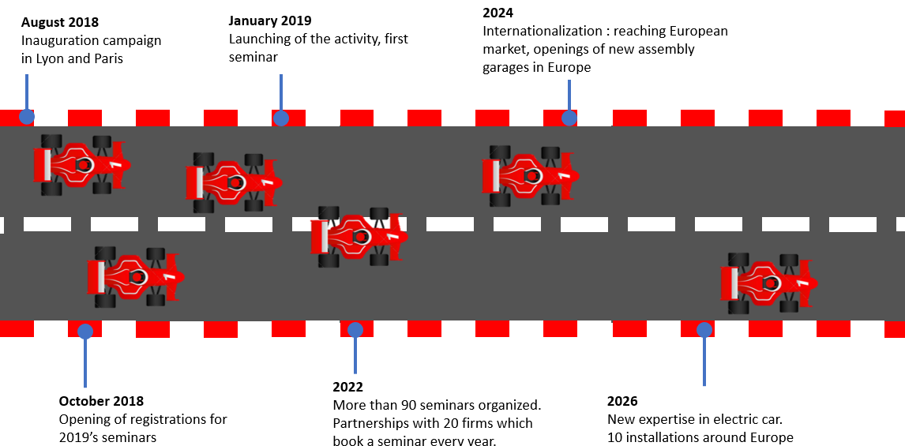

## V. 3. Communication

### V.3.1 Social networks



Facebook is an appropriate tool to follow the news on our company, improve our notoriety and show a modern facet. But Facebook is also an easy-to-use tool to organize public events and to get known quickly.



Twitter is a real time news tool we will use to give updates on our events, but it is also a way for our clients to talk about their experience during our seminars and advertise our service to other companies.



Instagram is a social network gaining a strong influence among the youth and young professional people. We will use it to post pictures of our seminars, the performances of the ephemeral cars, and of course to encourage more and more people to try our seminars and thus earn public credibility.



We will also use YouTube for the same purposes we will use Instagram. Besides, videos make it possible to show in detail what we propose to our clients, in an attractive form.



’

LinkedIn allows companies to catch professionalsis attention with very efficient and dynamic tools such as Sponsored Content, Sponsored InMail, Display Ads, etc …



A clear website, designed by professionals, advertises and sells our offers.



Of course, intensive mailing is part of the online communication as it reaches many potential clients at once.

### V.3.2 Off-line communication

*Canvassing new clients*

The most important aspect of our communication policy is canvassing new companies by meeting managers and directors, convincing them that our product would bring self-confidence, teamwork improvement, work happiness and love for their company to their teams.

*Participating to car exhibitions*

Another aspect of our off-line communication is our participation to car exhibitions to build our brand image among any company and race car amateur. Indeed, car amateurs will recognize our professionalism and the highly performant cars our clients will work on and assemble. That is why our notoriety and our credibility relies on this class of persons.

*Communication kit*

A communication kit has been designed to be used for those occasions and during any business canvass.

*Launching party*

When launching, we will organize a launching party gathering companies and race tracks s representatives and managers so as to initiate the acquisition of future clients and partners. This is an effective way to prepare future negotiations with clients and to start creating our brand image.

’

# Planning stage

Our first logistic step is to launch our communication. The inauguration in Lyon and Paris will permit to gain some recognition in the sector of seminar organization. We decided to do a wide communication campaign in order to attract potential clients and to create partnerships in the long term with firms which send their employees at seminars every year and of course race tracks representatives.

’

Then we can book our first race tracks for the 2019 year, while having already started canvassing for clients. We will have to fill every race track booking with seminars, that is why a strong communication campaign is absolutely crucial.

Once a client finds a date available on our schedule he can book the seminar. Then we take care of everything thanks to our partnerships with the hotels in the area. We can also propose a transportation service between the company s office and our garage where the seminar take place but only as extra, and we will charge the client for it.

’

When our company will be known enough, instead of booking rooms in hotels we will secure regular time slots with them. This should be possible within 3 years and it would help us increase the strength of our community.

# Financial aspects

## VII.1. General course of action

The accurate planning we made here above will permit us to have a precise idea of the financial resources we will need. But inevitably, there is also some uncertainty about sales volume, that is why we based all our predictions on two hypotheses : the high hypothesis – where the company is very successful – and the low hypothesis – where the company has more difficulties to shine at start. All the explanations about our approach will be illustrated by tables **from the high hypothesis.** Tables from the low hypothesis are included in the appendix, page ?

Obviously, all the costs associated with the launch of the company are the same, regardless of the assumption considered.

## VII.2. Fixed costs

### VII.2.1 Marketing and communication

We decided to consider the creations of previous companies and to ask around us to set a budget of around €100,000 for the first year, to give us the opportunity to develop and improve our brand image and brand recognition. The following years will have a budget of €50,000, which is consistent for maintaining a good notoriety after the start spike.

We decided in the first year to allocate a large part of our budget to the launch of our brand. the objective is to create expectations among future customers and stand out immediately in a very competitive sector. The rest of the budget should be allocated to various promotional methods, by advertising or by showing the assembled car on race circuits.

Our goal as noted above, is to limit the cost of the department related to our business. On marketing and creating partnerships, we expect to benefit from commercial advantages so as to considerably reduce variable costs, as we will see further.

### VII.2.2 Real estate

*Headquarters*

Our office is located in Lyon - France. We rent it every month for €710 (charges included). It is a 26 squares meters office, divided in two rooms. It is enough for two computers and for meetings with potential clients or partners.

*Warehouse/Assemblyegarage*  
We rent a warehouse which is used as an assembly garage. This is the main place for the seminars. Its surface is 100 squares meters which will permit to store all our tools and to set different workshops for the different part of the vehicle. It represents a cost of €560/month (taxes and charges included).

*Insurance*

We chose Insurance Pro entrepreneur with maximum guarantees for €8,400:

-Liability (Break of the screen of a computer assigned to repair …)

-Legal protection (Delay of a supplier to deliver the goods essential to our business)

-Local and business property (fire, explosion, glass breakage, water damage, theft …)

-Financial protection (if damage, while electricity-type loads continue to be paid)

-Vehicle

*Electricity*

We will have €200 annual subscription with EDF, the French electric service company corresponding to 12kWh. We also plan to have a phone and an Internet subscription for our office which costs €85 per month.

### VII.2.3 Wages

Wages are significantly the biggest part of our fixed costs. Here are the different employees we will pay, in addition to the CEO and the marketing director:

* Engineer: Its role is to seek for kits that are more or less easy to assemble on the vehicle. He is an expert on the assemble process, security rules, skill and time requirement for the integration. We employ 1 engineer for the first year, that we pay €34,000 net.
* Commercial: Its role is to sell our innovative concept to potential customers. He is extremely mobile and knows perfectly well the service we propose, and how it will certainly help the client to improve its executives’ productivity and engagement. We employ one commercial for the first year, that we will pay €32,500 net.

’

* Animator: Its role is to take care of the whole customer’s group during the 3-day seminar. He is able to understand the persons’ will, and propose different solutions to lead them to the vehicle they eventually want to build. He is very sociable and careful. Animators are the basis of our concept, as a teambuilding service, that’s why they represent a large majority of our employees. We will employ one animator for the first year, that we will pay for €20,000 net.

According to the hypothesis considered, wages are increasing in diverse ways, as well as employment policy.

### VII.2.4 Reference car

We will assemble ourselves the reference car, with parts and kits we will buy on the market. We evaluate this cost at €50,000.

### VII.2.5 Furniture

We will buy desks, computer hardware, shelves and racks for headquarters (administrative and design department) and warehouse (seminar location). We will also buy a TV on the fifth year, to improve our welcoming ability and the efficiency of meetings.

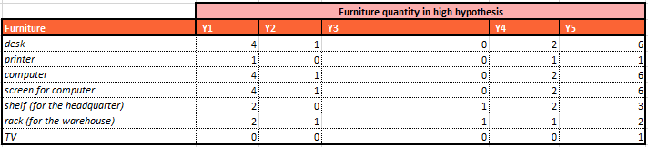

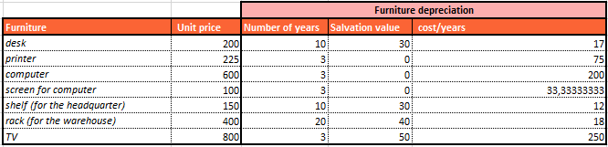

### VII.2.6 Company car for commercials

As said previously, it is important to have very mobile commercials, because we will need first to meet our clients by ourselves, given our low recognition. We will purchase a company car on the second year for this purpose, and other cars later.

### VII.2.7 Additional parts and kits

Our concept relies on the various possibilities of vehicle one can build from the reference car. That is why we plan to get a considerable stock of parts and kits that we can set in place and remove easily. Each year this stock will increase, so we will expand our offer. We will start with a €20,000 worth stock.

### VII.2.8 Toolings

Some toolings will be also necessary for the assembly, such as toolboxes etc… We will assign a tooling budget of €1000 for the first year, and more for the next years so as we can adapt our means to the new kits we will get.

### VII.2.9 Website

We will charge a professional firm for the development of our website. Its aim is to explain who we are, what is our concept, how to contact us, and to show some pictures and features that will spotlight the benefits of our product for companies, so it is mainly a showcase. Such a development usually represents a €12,000 investment. We will also pay €500 per year for its maintenance.

### VII.2.10 Accounting

We will charge a professional firm for accounting, as well, for €400 per month. We plan to implement our own accounting service in the future, for more autonomy, but it is not a priority, since wage expense will be far higher than the price of a professional firm.

### VII.2.11 Brand protection

**Register the trademark of VULCANIX**

According to the website of the INPI (National Institute of Intellectual Property), the trademark VULCANIX is available. We want to register the trademark because many companies are currently doing business around race cars and it will be an asset for us in the future to have the monopoly on this brand, which also will serve as a trade name. The cost of a trademark registration is €200.

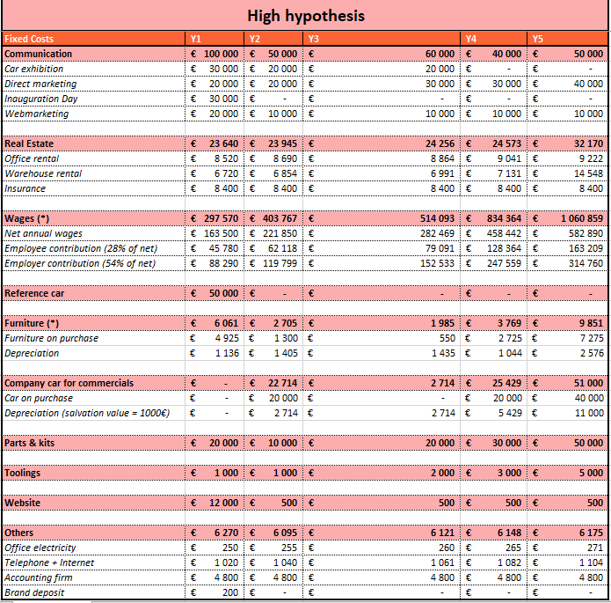

## VII. 3. Variable costs

Our variable costs are due to circuit booking + pilote teaching (€1,180 **per seminar**), delivering people + the car on the circuit (€850 **per seminar**) and provide rest and food to our customers (€750 **per person**). We believe that on being a regular client to hotels in the area, we will manage to lower that latter cost at €600 on the fourth year. In order to keep a regular final price growth, and counting on our well-established notoriety at this time, we will increase more significantly the margin we make to compensate the reduction for our clients, because that is not what we want, for now.

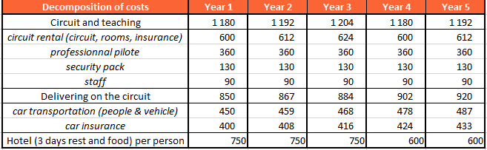

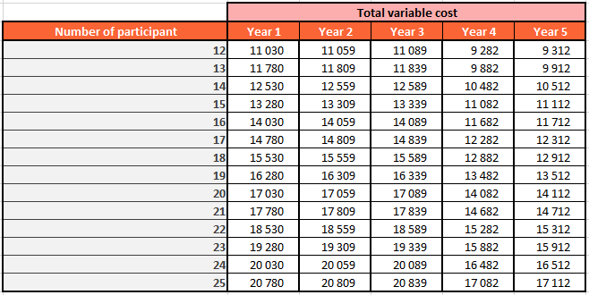

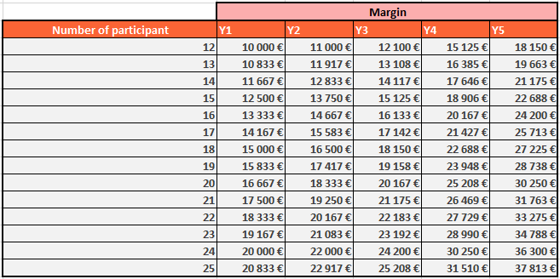

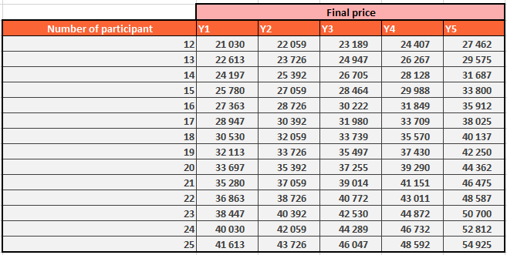

## VII. 4. Profit and losses

Our turnover and expenses highly depends on our sales volume, so we introduced 2 scenarios. In the high hypothesis, it is described here below :

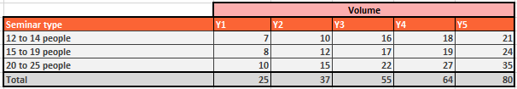

These sales volumes are the very cause that made us adjust our expected expenses such as fixed costs, and financial parameters, to keep being profitable. In the low hypothesis, sales volumes are described on page **?**.

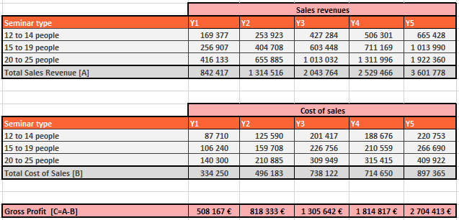

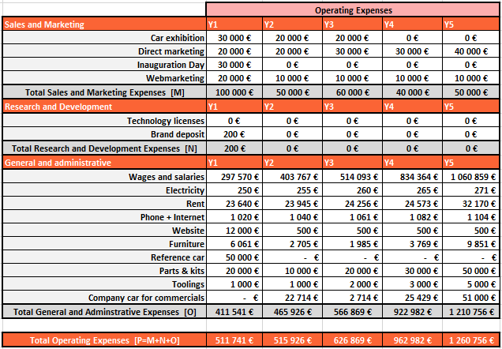

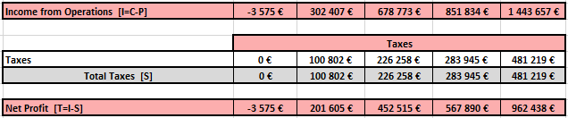

## VII. 5. Financial analysis of the company

### VII.5.1 Input data

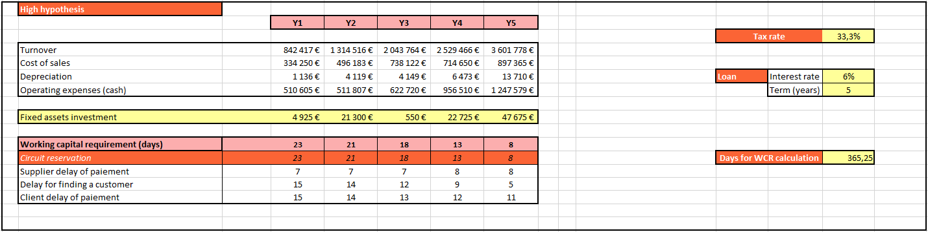For this analysis, we need the information in the table right :

*Figure VII. 8 : Input data*

Over time, we believe that we will manage to reduce the client delay of payment and negotiate a higher supplier delay of payment. We also assume that our success will make it possible to find a client more quickly, 5 days for instance at the 5th year. All these reasons lead to a decreasing working capital requirement (= change in working capital), which is very positive for flexibility and quick reaction to the market.

To launch our company, we will do a large communication campaign and buy a lot of assets and products. All the glorious years in the future rely on our first breakthrough, so to ensure this, the members of the team will bring €110,000 and investors should bring €90,000. In addition, we will make a loan of €75,000, and then the activity will start efficiently.

### VII.5.2 Statement of income

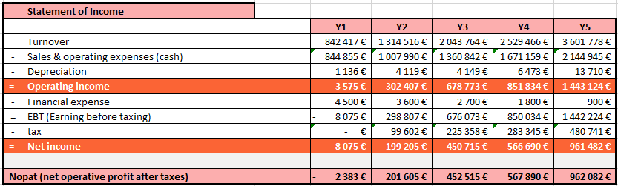In the high case, we have a slightly negative NOPAT on the first year, which become positive on the second year, and keeps growing exponentially:

*Figure VII. 9 : Statement of income*

Therefore, our NOPAT breakeven will happen early in the second year

### VII.5.3 Cash flow statement

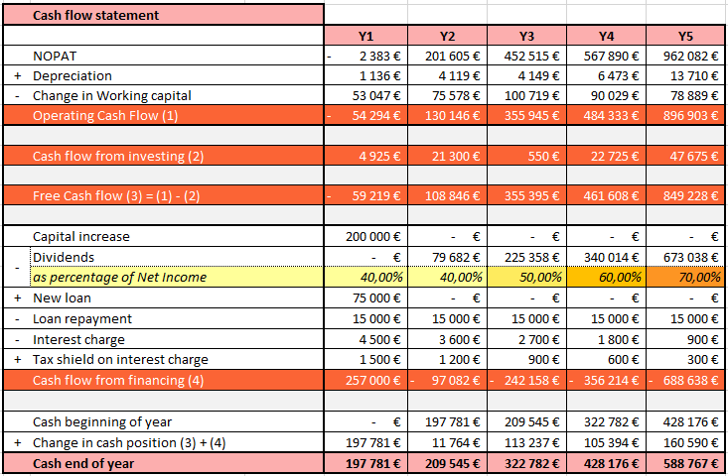

*Figure VII. 10 : Cash flow statement*

We can see that our cash at the end of the year is always positive. We do not expend it during the five first year (although we distribute 70% of our net income as dividends to shareholders like investors) because we plan to get machines and other sites in Europe, thanks to this provision.

### VII.5.4 Balance sheet & and indicators

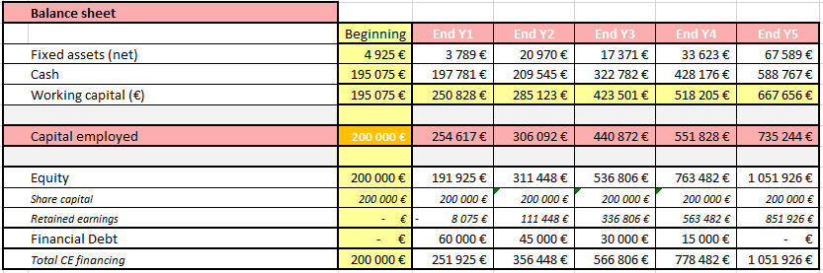

*Figure VII. 11 : Balance sheet*

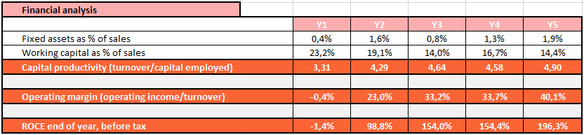

*Figure VII. 12 : Financial analysis*

Thus a financial analysis shows that our capital is well used since it reaches a highly positive return on capital employed on the second year : 98.8%, and 196.3% for the fifth year.

### VII.5.5 Graphs

*Figure VII. 13 : Financial overview*

*Figure VII. 14 : Net income and dividends*

*Figure VII. 15 : First year fixed costs distribution*

€ 3,860,274

*Figure VII. 16 : Fixed costs distribution over the five first years*

### 

### VII.5.6 Financial summary

Investors will help the company to start on the right way, by providing the key support for intense communication campaign and fixed assets that are necessary. In return, VULCANIX will pay them on an increasing percentage of the net income, **making their initial invested money back within 2 years and 1 month.**

In the low case, this duration is only 2 years and 11 months.

Furthermore, we keep a positive cash at the end of the each year, and a good ROCE, which make our company **not only safe, but also extremely profitable**.

According to the low hypothesis, our cash is also always positive (page **?**). And because we have less capital employed, we have a better capital productivity (although turnover is lower), and our ROCE even gets higher than in the high case, reaching more than 350% after 5 years.

Thus, we verified the viability of our project, while considering a fall-back scenario.

# Legal aspects

## VIII. 1. Setting up a private limited company

The most appropriate legal status for a company like VULCANIX is the SAS, Société par actions simplifiées, or in English, Simplified Limited Liability Company.

A major advantage of SAS is its flexibility and the emphasis placed on freedom of contract, which allows us to write custom statuses. The SAS can be created by several partners who freely define the shared capital of the company. The capital contribution can be made either in cash (money) or in kind (real or personal property).

Shareholders are liable for debts to the extent of their contributions. As for the leaders, they may have their civil and criminal liability in case of serious mismanagement. Since Law No. 2008-776 of August 4, 2008 of the modernization of the economy, the legal system of SAS was relaxed. The requirement for a starting capital of € 37,500 has been removed, and there is now no more minimum capital to have. Pursuant to Article L. 227- 2 of the Commercial Code, it now belongs to the founding partners of SAS to freely determine the amount of capital in the statuses. Moreover, the presence of an auditor became optional in SAS.

Besides, all the executives are assimilated as employees, and thus, benefit from social welfare planned by the general social security system.

For all these reasons we have chosen to create a SAS rather than a company with a different legal form.

## VIII. 2. Ownership

The company has members (people) who own the company through shares.

Directors are responsible for running the company. However, owning company shares is not mandatory for these executives.

’

The responsibility of the company lies in its shares. It means that the shareholders’ responsibility for the companyis financial liabilities are limited by the value of the shares they own.

’

Every financial year, the company must put together statuary accounts, send an annual report to Greffe au tribunal de Commerce (Registry at the Commercial Court).

## VIII. 3. Profit and tax

When the company is making profit, after the corporate tax is paid, the company can share its profits.

### VIII.3.1 Registering a limited company

It is possible to register a private limited company online on the following website: http://www.cfenet.cci.fr/. One needs the companyis name and address, as well as the directorsi names and addresses, the various shareholdersi positions and the required capital.

’

’

’

’

’

### VIII.3.2 Filing the companyis accounts tax return

’

One may complete the companyis accounts tax return online: www.impots.gouv.fr. In order to do so, it is required to register by using the SIREN code supplied by the Chambre des Metiers (Chamber of Trade) in our case: the SIREN number is your unique French business identification number. This 9-digit number will be requested by all French administration when dealing with you. Complete company accounts and the corporations complete tax calculations are required.

## ’

## VIII. 4. Authorsis rights

’

“Authoris rights” is used in European Union Law and is only part of copyright law. Authors' rights are internationally protected by the Berne Convention for the Protection of Literary and Artistic Works.

## VIII. 5. Trademark

A logo makes a brand recognizable. Anyone who wants to trademark a logo needs to apply through the Institut national de la propriete industrielle (National Institute of Industrial Property) (INPI). If a trademark is granted, it will be added to the INPI database.

é

é

The trademark registration is valid for 10 years in the countries where it is registered. The trademark can be renewed every 10 years for the same period.

## VIII. 6. Employed staff

To spread our workload, expand production and take advantage of skills and expertise, the following must be taken into account :

The salary that the company wants to pay must respect the national minimum wage and must be written in the employment contract.

Employees must be legally allowed to work.

## VIII. 7. Register employees with Work inspection

We must send job specifications to employees that include terms and conditions.

We will constitute a unique employees register that gives for each employee : Name, nationality, date of birth, gender, work position, qualification, hiring date.

# Conclusion

This project has got ambition and a lot of guts. Nowadays, participating to incentive seminars is getting very common for modern companies, but thanks to our market analysis, we targeted a new way of doing it: by combining pondering, handcraft, and of course sensation, we can offer the most complete teambuilding experience. We strongly believe in the viability of our project: the benefit expectations for the first years and the many possibilities we identified to expend our market are proofs of a serious company that could be launched right away.

VULCANIX is the perfect balance between high sensation and an affordable budget (around €2,000 per person). Our customers will discover something new, something original, something sensational they will talk about. VULCANIX vocation is to create a striking experience into peopleis head to gain their loyalty and trust.

’

The association where this project comes from, EPSA, has always had a politic opened to educational profit and being the first step for its members to launch a company is the ultimate step. Its members are used to work together and to be efficient, no matter the obstacles. This is a strength that will help our team launch this company and make it successful.

’

To make this dream possible, we need investorsi support. This document precisely showed how their money will be used and why it is worth it to become a shareholder. So why not join the adventure, and make money in the same time ?

# Appendix

## X.1 Financial aspects: the low hypothesis

### X.1.1 Fixed costs

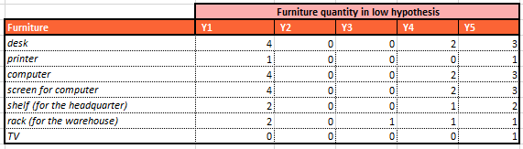

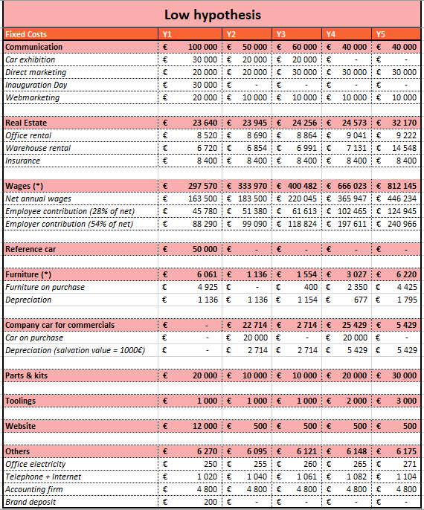

### X.1.2 Variable costs

Variable costs are exactly the same as in the high case.

### X.1.3 Profit and losses

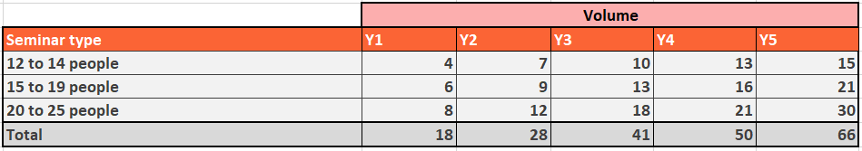

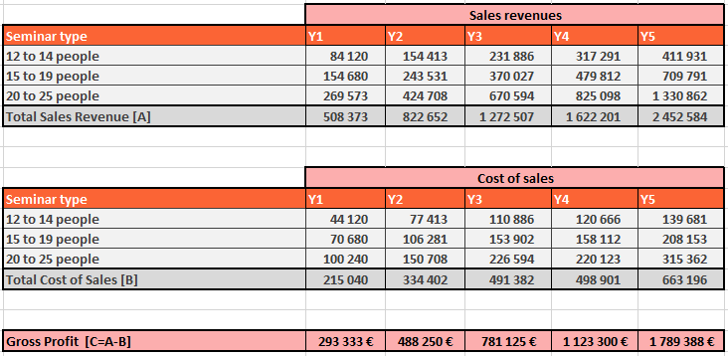

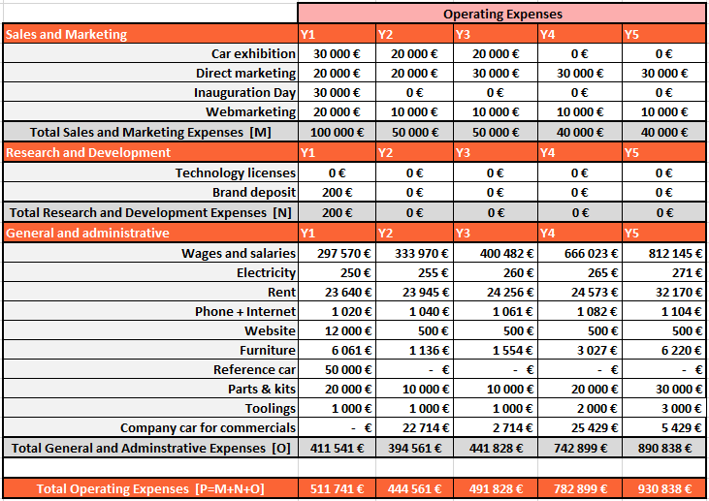

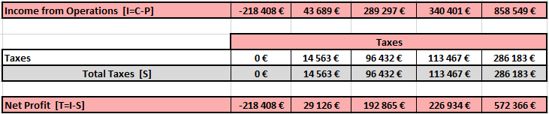

### X.1.4 Fiancial analysis : Input data

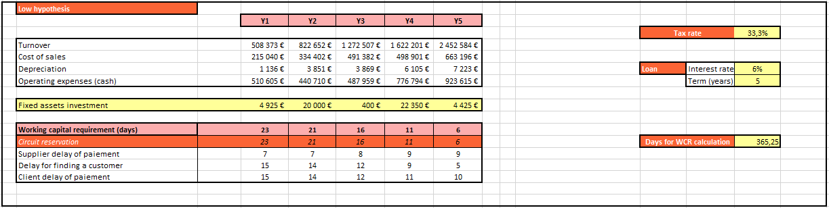

### X.1.5 Statement of income

### X.1.6 Cash flow statement

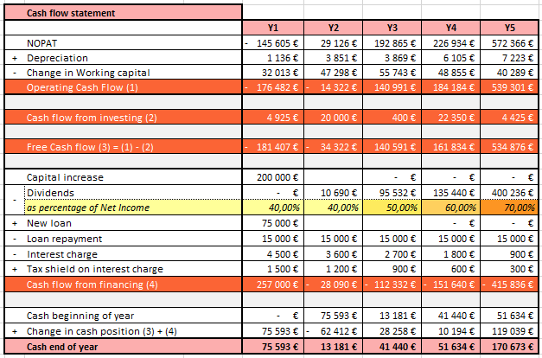

### X.1.7 Balance sheet & indicators

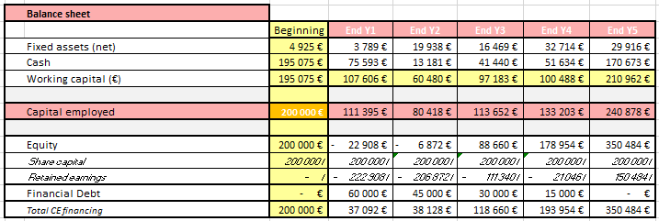

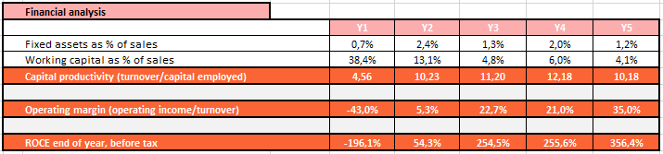

**A faire :**

* **Éventuellement plus d’annexes**
* **MAJ table**
* **Nom des figures**
* **Table des figures**
* **Mise en page**